

***Available online at***

[*https://jurnalteknik.unisla.ac.id/index.php/CVL*](https://jurnalteknik.unisla.ac.id/index.php/CVL)

*icon-doi*[*https://doi.org/10.30736/cvl.v2i2*](doi:%20https://doi.org/10.30736/cvl.v2i2)

**Analysis Of The Precast Half Slab Method In Batang I Industrial Workers Flats Development Project**

**Iqbal Muttaqin1*, Nasyiin Faqih2, Suharto3**

1*Civil Engineering, Faculty of Engineering and Computer Science, Universitas Sains Al-Qur’an*

Email: [*iqbal.muttaqin.583@gmail.com*](mailto:iqbal.muttaqin.583@gmail.com)

|  |  |  |
| --- | --- | --- |
| A R T I C L E I N F O |  | ABSTRACT |
| ArticleHistory :  Article entry :  Article revised :  Article received : | The Batang I Industrial Worker Flats project is located in the Batang Integrated Industrial Estate. In the highly advanced construction era, many projects are competing to innovate to produce a building that is fast and efficient. This project uses the precast half slab method, where half of the floor slab is printed offsite (precast) with a thickness of 7 cm and the other half is in place (topping 5.5 cm). This final project analyzes the precast half slab method used by comparing it to the conventional method in terms of cost and time, so it can be seen which method is more profitable. The analysis of the precast half slab method focuses on calculating the direct cost of conventional half slab precast both in terms of materials, tools and worker wages, as well as calculating the time needed for each job. The analysis starts from a literature study, then collects project data, followed by calculating the time and calculating the cost of carrying out the floor slab work between the half slab method and the conventional method until the result is found or the difference between the two methods. The results of the Analysis of the Half Slab Precast Method in the Stem I Industrial Worker Flats Development Project, namely the precast half slab method takes 5.83 days at a cost of IDR 614,412,689.19 while the conventional method takes 6.18 days at a cost of IDR 670,661,242.64. So that the more profitable implementation method is the precast half slab because it is faster and cheaper. For work that is more effective and efficient, it is necessary to pay attention to the determination of the type of half slab which is more uniform, not too many types. And the half slab precast method is very possible to apply to today's fast-paced projects. |
| Keywords :  Half Slab, Conventional, Cost, Time |
|  |

**1. Introduction**

In competition to complete a project with good quality and a short time, a contractor is required to innovate in carrying out the work of a project. In the Batang I Industry Worker Flats Development Project, using the Lean Construction / Downsizing Method. Where the goal of Lean Construction is to maximize the value to be achieved by minimizing waste. This study will analyze one of the methods, namely the use of precast half slab formwork on reinforced concrete slabs of the Batang I Industry Worker Flats Development Project. The puIDRose of this study is to analyze the application of the use of precast half slab formwork using conventional formwork in terms of cost, time and implementation stages.

In today's advanced construction world, all contractors are competing to offer construction products that are of good quality and have a shorter and cheaper implementation period. Based on the above, the Batang I Industrial Worker Flats Development Project is one of the national strategic projects planned by the Government through the Ministry of Public Works and Public Housing. In total there are 10 tower buildings that are being worked on, out of 10 towers PT.PP (Persero) Tbk, entrusted to work on 4 towers, while 3 are being worked on by PT Abadi Prima Inti Karya, and 3 more are being worked on by PT Brantas Abipraya. Each tower consists of 5 floors with the same type of structure and has a short time, so that the work can be completed quickly and simultaneously, the PT. PP (Persero) Tbk Project uses the Precast Half Slab system. The advantages of using the Precast Half Slab method include:

1. Acceleration of work in the field, especially in formwork systems compared to conventional systems.

2. There is no formwork demolition work so that the efficiency of the use of tools in the field.

3. Cost efficiency compared to conventional systems.

**2. Methodology**

In the Analysis of the Precast Half Slab Method in the Construction of Workers' Flats in the Batang I Industry, the method used is to compare the precast half slab method with the conventional method in terms of work time and implementation costs. So that you can get which method is faster and which is cheaper.



Figure 1. Research Flowchart

**3. Results and Discussions**

Cost analysis for slab work using the Precast Half Slab and conventional methods is calculated using the RAB (Cost Budget Plan) of the Batang I Industrial Worker Flats Development Project.

Table 1. List of Wage Unit Prices



Table 2. Material Unit Price Data



Table 3. Tower Crane Rental Price Data



Table 4. Data on Equipment Rental Prices and PCH



1. Price Recapitulation Analysis of Precast Half Slab Plates Method

The building structure of the floor slabs on the Flats is designed with a length of 64.8 meters, a width of 22.8 meters, with a thickness of 125 mm slab (70 mm precast half slab and 55 mm topping), and 250 mm x 450 mm beam supports. With the type of precast half slab, namely 17 types.

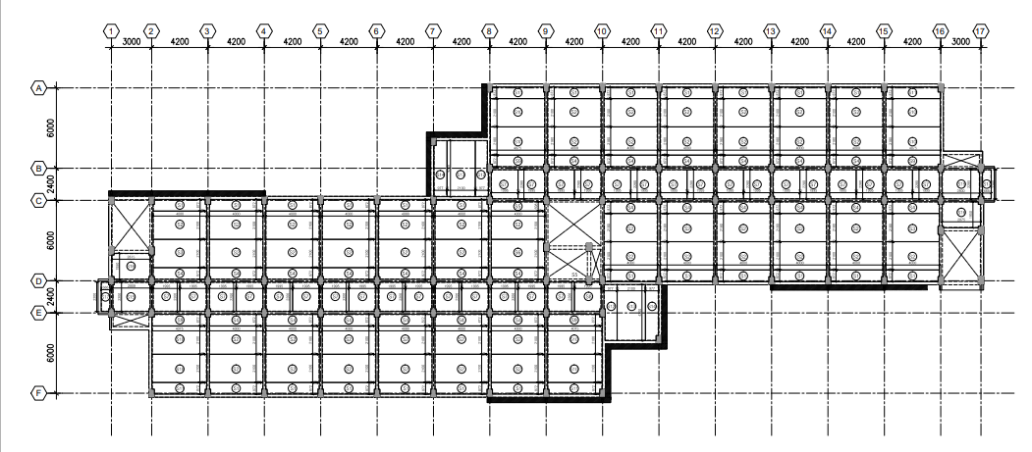 Figure 2. Half Slab Plate Plan

Table 5. Various Types of Half Slab Precast Plates



Then the results for the recapitulation of plate prices with the precast half slab method are as follows:



For a total wage of IDR 13,594,865.85, materials and materials needed IDR 317,329,290.00, and tools needed IDR 283,488,533.34, so the total cost for floor work with the Half Slab precast method is IDR 614,412,689.19.

2. Work Price Recapitulation Analysis for the Conventional Plate Method

The dimensions for conventional slabs are the same as those for the precast half slab method, without distinguishing dimensions, namely 64.8 meters long, 22.8 meters wide, and 125 mm thick.

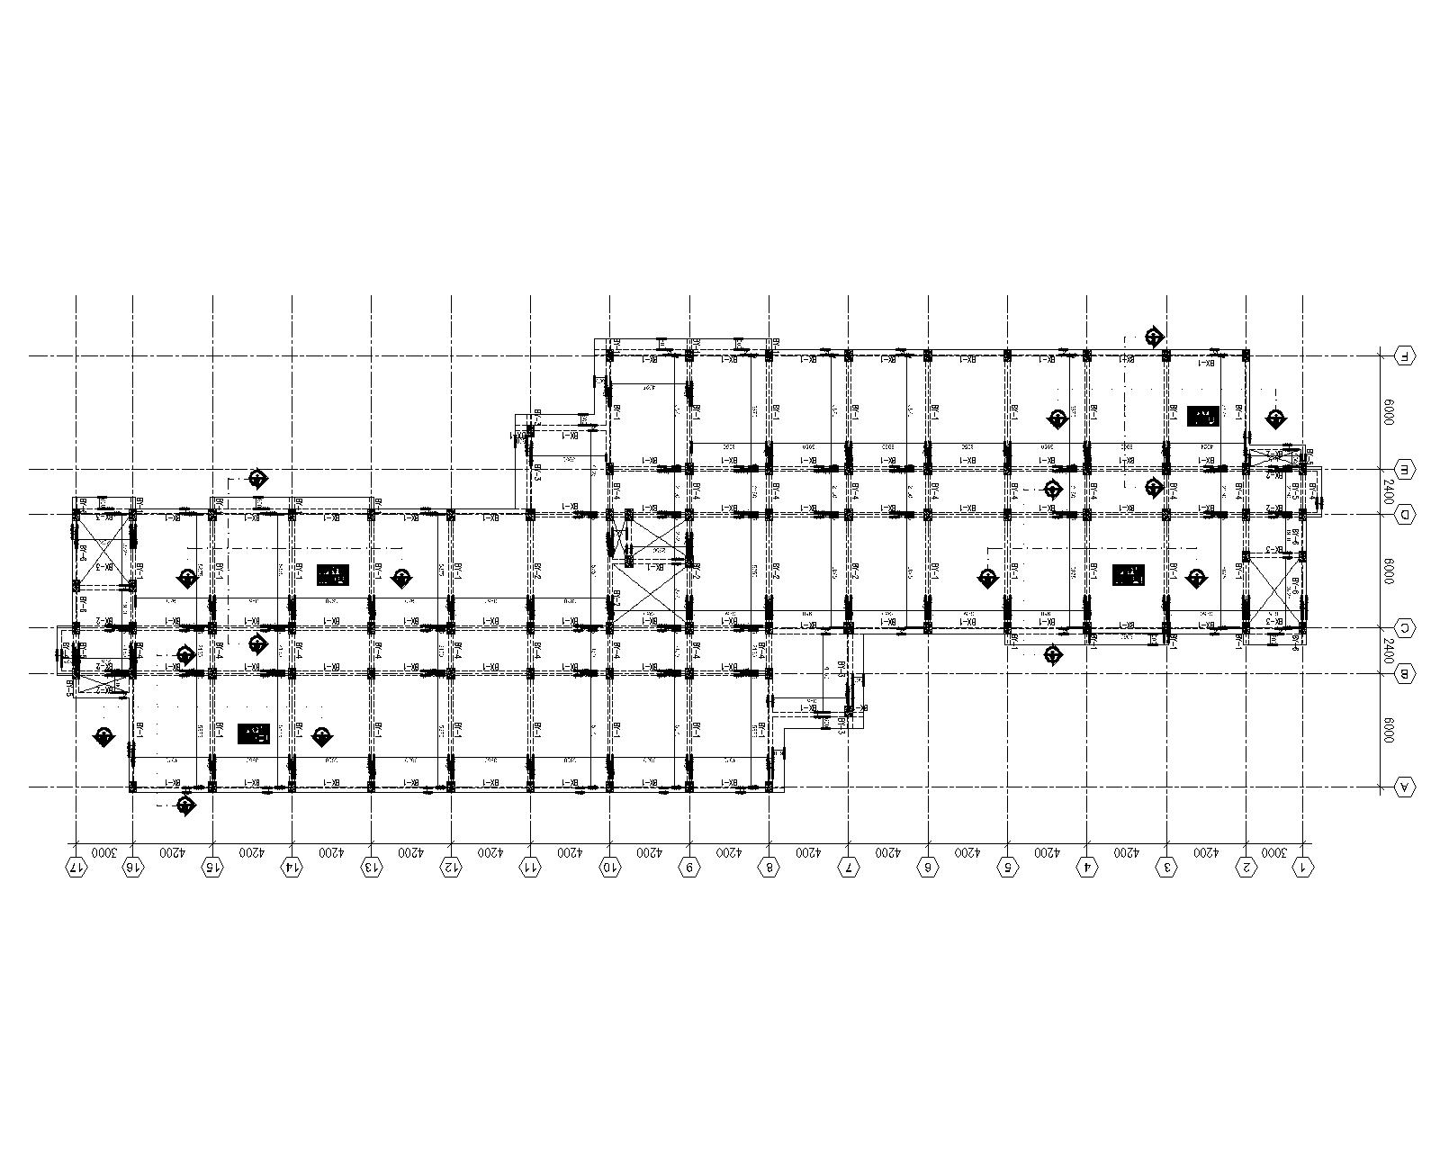 Figure 3. Plan of the Conventional Plate

Table 7. Conventional Method Plate Fee Recapitulation



For a total wage of IDR 15,025,401.90, the need for materials and materials is IDR 372,147,307.40, and the need for tools is IDR 283,488,533.34, so the total cost for floor work with the Conventional method is IDR 670,661,242.64.

3. Work Time Analysis of Half Slab Precast Plates

Time analysis for calculating precast half slab work time is calculating the time needed for each work item based on work volume and work productivity.

Table 8. Recapitulation of Total Time of Slab Precast Half Slab Method

|  |  |  |
| --- | --- | --- |
| No | Type of Work | Time |
| 1 | Half Slab Manufacturing Work | 2 day |
| 2 | Wiremesh Topping Floor Reinforcement | 2.35 day |
| 3 | Scaffolding Work | 0.46 day |
| 4 | Installation of Precast Half Slabs | 0.88 day |
| 5 | Floor Plate Topping Casting | 0.14 day |
| Total | | 5,83 day |

4. Analysis of Conventional Plate Working Time

Time analysis for conventional plate work, namely calculating the time for each job based on work volume and productivity.

Table 9. Recapitulation of the total time of conventional method plate work

|  |  |  |
| --- | --- | --- |
| No | Type of Work | Time |
| 1 | PCH Scaffolding Work | 0.46 day |
| 2 | Formwork Work | 0.13 day |
| 3 | Redemption Work | 5.31 day |
| 4 | Floor Plate Casting | 0.28 day |
| Total | | 6,18 day |

5. Construction Calculations

For the removal of slabs from the mold according to SNI concrete standards 7 days (30% fc strength) but in the world of increasingly advanced construction there is a need for acceleration, given the many needs and limited time in the project. So that the removal of the half slab is carried out after the concrete has aged 24 hours or one day.

For the lifting example, the half slab type is taken which has the largest dimension, namely with the data:

|  |  |  |  |  |  |  |  |  |  |  |  |  |  |  |  |
| --- | --- | --- | --- | --- | --- | --- | --- | --- | --- | --- | --- | --- | --- | --- | --- |
| Lebar halfslab | | |  |  | (Lx) |  | b | = | 2100 |  |  |  | mm | |  |
| Panjang halfslab | | |  |  | (Ly) |  | L | = | 4200 |  |  |  | mm | |  |
| Tebalhalfslab | | |  |  |  |  | h | = | 70 |  |  |  | mm | |  |
| Tebal topping cast insitu | | |  |  |  |  | h1 | = | 55 |  |  |  | mm | |  |
| Selimutbeton | | |  |  |  |  | p | = | 20 |  |  |  | mm | |  |
| Tulanganlentur | | |  |  |  |  |  | = | D | 8 | - | 150 | mm | |  |
| Tulangansusut | | |  |  |  |  |  | = | D | 8 | - | 150 | mm | |  |
| As |  |  |  |  |  |  |  | = | 334.93 |  |  |  | mm2 | |  |
| Mutubeton (umur 1 hari) | | |  |  |  |  | K | = | 99.4835 | kg/cm2 |  | f'c | = | 8.26 | Mpa |
| Mutubaja | |  |  |  |  |  | fy | = | 500 |  |  |  | Mpa | |  |
| Beratjenisbeton | | |  |  |  |  | γc | = | 2400 |  |  |  | kg/m3 | |  |
| Tinggi efektifdinding | | |  |  |  |  | d | = | 38.00 |  |  |  | mm | |  |
| Koefisienbebankejut | | |  |  |  |  | k | = | 2 |  |  |  |  |  |  |
| Modulus elastisitasbaja | | |  |  |  |  | Es | = | 210000 |  |  |  | Mpa | |  |
| Umurpengangkatan | | |  |  |  |  | t | = | 24 |  |  |  | Jam | |  |
| Jumlah handling loop | | |  |  |  |  | n | = | 8 |  |  |  | Buah | |  |
| Mutubaja handling loop | | |  |  |  |  | fy | = | 420 |  |  |  | Mpa | |  |
|  | | |  |  |  |  |  |  |  |  |  |  |  | |  |

1. Loading

Dead load (DL) =(t)×γc=0.7×2400=168 kg/m2

Shock load during lifting and installation (especially slab slabs)

=2×(DL)=2×168=336 kg/m2

Live Load (LL)=0 kg/m2

Ultimate Load (Wu) =1.2DL+1.6LL=1.2(168)+1.6(0)=403.2 kg/m2

Load for 1 m of sheet width (qu) =(Wu)×1=403.2×1=403.2 kg/m2or 4.032 N/mm

b. The moment that happened

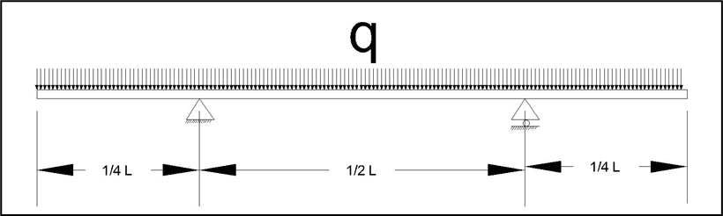

Figure 4. The Moment That Occurs During Lifting

$$Mu=Mmax$$

$$Mmax=175,0329 kgm=1.750.329,00 Nmm$$

c. Moment Capacity (Mn)

rb $=\frac{0,85×f'c×b}{fy}×\frac{600}{600+fy}= \frac{0,85×8,26×0,85}{500}×\frac{600}{600+500}=0.00651$

rmax $=75\%×rb=75\%×0,00651=0,00488$

rmin $=\frac{1,4}{fy}=\frac{1,4}{500}=0,00280$

r ada $=\frac{As}{b×d}=\frac{334,93}{2100×38,00}=0,00420$

$T=As×fy=334,93×500=167466,67 N$

$$X=\frac{T}{θ×0,85×fc×b}=\frac{167466,67}{0,8×0,85×8,26×2100}=14,20 mm$$

$$Mn=T×\left(d-{0,5}^{*}X\right)=167466,67×\left(38,00-{0,5}^{*}14,20\right)$$

$=5.174.494,00 Nmm$**(Mn) > (Mu) = OK**

d. Concrete stress that occurs during lifting

$Cb=0,5×t=0,5×70=35$

$I=\frac{1}{12}×b×h^{3}=\frac{1}{12}×1000×{70}^{3}=28.583.333,33 {mm}^{4}$

$$σcm=\frac{Mmax×Cb}{I}=\frac{1.750.359×35}{28.583.333,33}=2,14 Mpa=21,4 kg/{cm}^{2}$$

e. Minimum concrete quality at lifting

$$σrm=σcm$$

$fcr={\left(\frac{σrm}{0,7}\right)}^{2}={\left(\frac{2.14}{0,7}\right)}^{2}=9,37 Mpa=93,7 kg/{cm}^{2}$

f. Concrete quality at age (t) hours

$$t =24 hours$$

$$fc\left(t\right)=3,057\left(24\right)+11,448=84,816 kg/{cm}^{2}$$

g. Deflection At Lifting

Modulus of Elasticity of Concrete = Ec

$Ec=4700\sqrt{fc'}=4700\sqrt{2,14}=6.880,74 Mpa$

$d occurs =\frac{0,586×L}{180}=\frac{0,586×4200}{180}=13,67 mm$

$d permit=\frac{5×qu×{(A2)}^{4}}{384×Ec×I}=\frac{5×4,032×{(2100)}^{4}}{384×6.880,74×28.583.333,33}=5,19 mm$

d occurs < d permit = **Safe Deflection.**

**4. Conclusion and Suggestion**

**4.1 Conclusion**

Based on the analysis carried out in the Final Project "Analysis of the Half Slab Precast Method in the Construction of Flats for Workers in the Stem I Industry", namely in terms of cost and time, it can be concluded that:

1. The half slab precast method is more profitable because it is faster than the conventional method, which only takes 5.83 days, while the conventional method takes 6.18 days. Then in terms of cost it is also cheaper because the precast half slab method only costs IDR 614,412,689.19, while the conventional method requires IDR 670,661,242.64.

Table 5.1 Recapitulation Data of Total Time and Total Cost of Floor Slabs Precast Half Slab and Conventional Slab Method

 Table 5.2 Difference in price per m2 of Floor Plate Precast Half Slab and Conventional Plate Method

|  |  |  |
| --- | --- | --- |
| Description | Half Slab Precast Plate | Conventional |
| Price per Floor | IDR 614.412.689,19 | IDR 670.661.242,64 |
| Area per Floor (m2) | 1053,99 | 1053,99 |
| Price per m2 | IDR 582,939.77 | IDR 636,307.03 |
| Difference per m2 | IDR 53,367.26 | |

2. Constructionally the half slab method is safe for application in the field with proof that the precast half slab can be lifted in 1 day.

3. Based on the calculation of the moment capacity (Mn) at the time of lifting, the result is = 5,174,494.00 Nmm which is greater than (Mu) = 1,750.329.00 Nmm.

(Mn) > (Mu) = Repeat OK

4. Based on the calculation of the deflection that occurs when the lifting is produced, d = 5.19 mm is smaller than what is allowed d = 13.67 mm.

d occurs < d permit = **Safe Deflection.**

**4.2 Suggestion**

Based on the analysis carried out in the Final Project "Analysis of the Half Slab Precast Method in the Construction of Flats of Industrial Workers in Batang I" namely in terms of cost and time, the suggestions that the author can give are:

1. The use of the precast half slab method is very possible to implement and apply to today's fast-paced projects, but for work effectiveness and efficiency it is necessary to pay attention to determining the type of half slab which is more uniform, not too many types.

2. Continue to think innovatively as the world of construction progresses, because it is possible that the knowledge we apply today will no longer be applicable in the future.

**References**

Badan Standarisasi Nasional.(2019). *Persyaratan Beton Struktural untuk Bangunan Gedung* (SNI-2847-2019).Jakarta.

Badan Standarisasi Nasional.(2013).*Beban Minimum Untuk Perencanaan Bangunan dan Struktur Lain*(SNI-1727-2013).Jakarta.

Ervianto, Wulfram I. (2006). *Eksplorasi Teknologi dalam Proyek Konstruksi*. Yogyakarta: Andi.

KH, Ir VSunggono. (1995). *Buku Teknik Sipil*. Bandung: Penerbit Nova.

Wisanggeni, Dimas Harya. (2017). *Perbandingan Sistem Pelat Konvensional Dan Precast Half Slab Ditinjau Dari Segi Waktu Dan Biaya Pada Proyek My Tower Apartement Surabaya.* Surabaya: InstitutTeknologiSepuluh November.

PT Pembangunan Perumahan (Persero) Tbk. *Precast Half Slab*. Jakarta

PT Pembangunan Perumahan (Persero) Tbk. *Work Methode Statement Proyek Rumah Susun Pekerja Industri Batang I.* Batang