Available online at
https://jurnalteknik.unisla.ac.id/index.php/CVL https://doi.org/10.30736/cvl.v2i2

Workability dan Sifat Mekanik Self Compacting Geopolimer Concrete

A R T I C L E I N F O |  | A B S T R A C T
Article History : Article entry : Article revised : Article received : |  | The purpose of this study was to investigate the relationship between molarity and workability in Self-Compacting Geopolymer Concrete (SCGC), as well as mechanical properties. Compressive strength and split tensile strength tests are used to characterize the mechanical characteristics in this research. Additionally, the study investigates the optimal molarity for self-compacting geopolymer concrete. Fly ash was used in lieu of cement in this research. On new concrete self-compacting geopolymer, workability is determined using the EFNARC standard, which includes the Slump Flow, V-Funnel, and L-Box tests. ASTM 39/C 39M-99 standard is used to determine the compressive strength of self-compacting concrete geopolymer. On new concrete, workability is determined using the EFNARC standard, which comprises the Slump Flow Test, a V-funnel, and an L-Box. Compressive strength of concrete samples is determined according to the ASTM 39/C 39M – 99 standard. The SNI 03-2491-2002 standard is used to determine the split tensile strength of concrete. At the ages of 7, 14, and 28 days, tests were conducted. The findings indicated that new concrete at 11M-13M satisfied the criteria for SCGC workability. Compressive and split tensile strengths of SCGC grow as the concrete ages. In self-compacting geopolymer concrete, the optimal molarity is 13 M.
Keywords :
SCGC, fly ash, compressive strength, split tensile strength, workability, air curing.

This work is licensed under a Creative Commons Attribution-ShareAlike 4.0 International License. Allows readers to read, download, copy, distribute, print, search, or link to the full texts of its articles and
allow readers to use them for any other lawful purpose.

Introduction
It is essential to use environmentally friendly and sustainable materials in order to achieve environmentally friendly city development. One approach to achieve an ecologically friendly city is to reduce and replace the usage of cement in building. Due to the fact that cement manufacturing generates CO₂, which contributes to the greenhouse effect, it is essential to use renewable resources that can perform the function of cement. Experts in concrete technology have started investigating the possibility of replacing all cement components with fly ash materials that include geopolymer linkages. Geopolymers are characterized as materials synthesized from polymers and alkali-silicate aluminosilicate, which results in a tetrahedral framework of SiO₄ and AlO₄ [1].
The mixed fresh geopolymer has rigid viscosity properties, so that the condition is not workability in the casting process. Workability of concrete is very necessary to facilitate implementation in the field. To overcome the problem of workability, in previous research there has been the discovery of one concrete innovation, namely Self Compacting Concrete (SCC). Concrete mixture that can be compacted without using a compactor (vibrator) is called SCC. The method commonly applied to obtain SCC concrete properties is to use admixture (viscocrete) materials.
Concrete is a building material that is often used because it has a high compressive strength. Concrete is composed of sand, gravel, cement, water, and additives if needed. But the use of cement in building materials actually causes a lot of harm to the environment. Which begins with the process of taking the material by dredging a lot of limestone. The production of cement will produce CO2 gas emissions in an amount that is proportional to the amount of cement that will be produced, so in other words the production of one ton of cement is the same as producing one ton of carbon dioxide into the air which causes environmental pollution. Cement used when mixing concrete will produce a lot of carbon dioxide gas [2].
Geopolymer concrete is a type of concrete that does not use cement at all but uses waste. The residue from burning coal can be used as a source of binder material in concrete mixtures. Geopolymer concrete is formed from a chemical reaction not from a hydration reaction as in ordinary concrete, in the manufacture of geopolymer concrete an alkali activator is needed which functions as an aggregate binder because fly ash does not have the same binding power as cement in general [1][2].
The commonly used activators are sodium hydroxide and sodium silicate. The function of sodium silicate is to accelerate the polymerization reaction, while sodium hydroxide has the function of activating the Al and Si elements contained in the binder so that it can produce strong polymer bonds [3]. Like cement, fly ash mixed with alkaline activator takes time to react until the concrete hardens. During the test, the setting time of cement depends on the type of cement and the amount of water used, then the setting time of fly ash is strongly influenced by the type of fly ash used, the fly ash/alkaline activator ratio and also depends on the molarity of the alkaline activator.
The aim of this research was to determine the connection between molarity and workability, as well as mechanical characteristics in Self Compacting Geopolymer Concrete. The mechanical properties described in this study are compressive strength and split tensile strength tests. Besides that, the research analyzes the use of optimum molarity in self-compacting geopolymer concrete.

Literature Review
Geopolymers are synthesized inorganic polymers that form three-dimensional polymer chains, usually during chemical reactions under alkaline conditions. The chemical mixing of the starting material and alkaline liquid leads to the development of the microstructure (microstructure) and mechanical properties of the final geopolymerization product. Fly ash geopolymer is an alternative binder material that is produced to reduce damage to nature and increase the potential for durability in the construction world [4].
Concrete is a composite material (mixture) of several materials whose main ingredients consist of a mixture of cement, sand, water gravel and or without other additives with a certain composition ratio. Because concrete is a composite, the quality of concrete is very influential with the concrete-forming materials used. One of the parameters used as a benchmark in the polymerization process is the adhesive used, namely SiO₂, H₂O and NaOH [5]. Previous studies have shown that geopolymerization can convert various aluminum silicate wastes into building materials with excellent chemical and physical properties such as fire resistance and acidic environments [6].
Geopolymer materials are composed of silica (Si) and alumina (Al) containing substances. As previously established, fly ash is a source of silica and alumina, that there are four dominant elements found in fly ash namely silica (SiO₂), aluminum (Al₂O₃), ferum (Fe₂O₃) and lime (CaO) [7] . The silica and alumina components found in fly ash are melted in an alkaline solution known as alkaline solution. The alkali solution is composed of Sodium Silicate (Na₂SiO₃), Sodium Hydroxide (NaOH), and Distilled Water (H₂O), each of which plays a significant part in the synthesis. Geopolymer synthesis is highly dependent on the beginning material conditions, particularly the characteristics of fly ash, the concentration of the geopolymerization process, and alkaline solutions [8]. Previous studies have shown that 100% fly ash can be used as a binder by activating it with alkaline components such as alkaline caustic, silicate salts and weak acid non-silicate salts [9].
Geopolymer synthesis technology relies on the activation of relatively simple bases from starting materials rich in silica (Si) and aluminum (Al) in amorphous form at relatively low temperatures [3]. In the geopolymer process, a chemical reaction occurs between silicate aluminum oxide (Si2O₅, Al₂O₂) and polyslic alkali metal, resulting in a Si-O-Al polymer bond. SCC is a fresh plastic concrete that flows easily because its own weight fills the entire mold, because the concrete can solidify itself without using a vibrator to compact.
According to Okamura and Ouchi (2003), One solution for strong concrete structures, depending on the possibility of construction work, is the capacity of self-compacting concrete, which can flow into every corner of the mold under its own weight and without the need for a vibrator, with a coarse-grained layer mix composition of 50% concrete, 40% fine aggregate by volume of solution and water-cement factor 0.25-0.40.
The advantages of SCC are that it is very runny, has a high slump for a long time (sludge retention additive), does not require manual compaction, is smoother and more stable, the compressive strength of concrete can be increased/very high quality, more water resistant, with less porosity and more shrinkage. less, more durable (stronger), smoother concrete surface, low noise pollution and more energy consuming.

Research Method
The method used in this research is a laboratory experimental method. The experimental method is a research that tests a hypothesis in order to find the effect, relationship, or difference of change. This research was conducted by looking for the effect of molarity on workability and compressive strength of self-compacting geopolymer concrete by performing workability tests which included slump flow, L-Box and V-Funnel tests.
The materials used in this research are
a. Fly Ash
The fly ash used is obtained from the PLTU Jeneponto in South Sulawesi. The fly ash used can be seen in Figure 1, the color and appearance of the PLTU Jeneponto fly ash
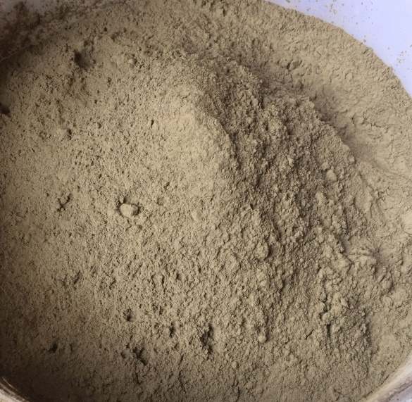
Figure 1. Fly Ash
b. Activator
Activator is an additive used in the binding process of a mixture of NaOh, Na₂SiO₃ and water
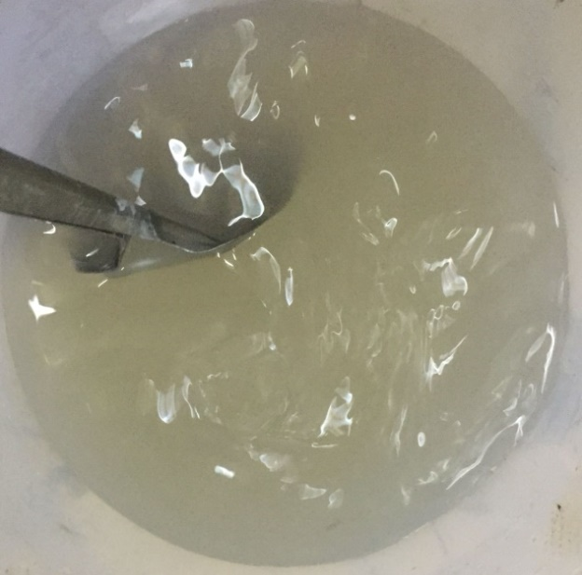
Figure 2 Aktivator
c. Water
The water used is PDAM water. Water is used to make activator
d. Aggregate
Coarse aggregate and fine aggregate are obtained from different sources, namely coarse aggregate obtained from the Jeneberang/Bili-bili river while fine aggregate is obtained from the Pinrang river. These aggregates are widely available in general aggregate sales places in the city of Makassar.
e. Admixture
The retarder used is the RTR-100 Retarder type and the Viscocrete used is the 43am Plastiumen type.
Mix Design use EFNARC [10]. The composition of the mixture for making Self compacting geopolymer concrete with a binder water factor of 0.4 using Fly ash from PLTU Jeneponto with a molarity variation of 11M, 12M, 13M, 14M and 15M with an alkaline modulus 2. Aggregate requirement 1: 0.65: 1.5 ( fly ash: sand: gravel) The viscocrete used is 2% of cemented rice and 3% retarder by weight of cement. The test object is cylindrical with an area of ​​100 mm x 200 mm. From the mix design calculation, it is obtained that the material requirements for 6 samples per 1 time of mixing are obtained.
For the compressive strength test, the test object is cylindrical with a size of 10 mm x 20 mm. The compressive strength test was carried out at the age of 7, 14 and 28 days. The compressive strength test method follows the standard ASTM C 39/ C 39M – 05 [11] and The split tensile strength test method follows the standard ASTM 39/C 39M – 99 [12]. The Universal Testing Machine (UTM) is used for testing the compressive strength by providing a uniaxial static monotonic compressive load with an average speed of 0.14 – 0.34 MPa/second. The compressive strength can be calculated by equation 1.
f’c= P/A (1)
Where f’c = concrete compressive strength (MPa), P = maximum load (N), A = surface area (mm)
For the tensile strength test, the test object is in the form of a cylinder with a size of 10mm x 20mm. The split tensile strength test was carried out at the age of 7, 14 and 28 days. The test object used was a cylindrical test object which was worked evenly along the diameter direction along the test object. The test object will split in half when the tensile strength is reached. Split tensile strength can be calculated in equation 2.
F'ct = 2P/(π.d.L) (2)
Where f_{ct} = Split tensile strength of concrete, P = Load at Split Time (N), d = Diameter of test object [mm], L = Length of Cylindrical Test Piece, = Phi (22/7) Previous Research on Geopolymer Concrete.

Results and Discussions
Test Workability SCGC
In this study, the workability of SCGC using air curing met the requirements at 11M-13M in the slump flow and L-Box tests, but none of the V-Funnel tests met the requirements, while at Molarity 14-15 the workability test results did not qualify as SCC. The results of the workability test of fresh concrete are shown in Table 1.
Table 1. Workability test results on SCC concrete
Molarity (M) | Slump Flow | V- | L-Box
 |  | Funnel | (H2/H1)
 | (mm) | (dtk) | Ratio
11 | 750 | 29,15 | 0,91
12 | 710 | 31,66 | 0,88
13 | 693 | 36,53 | 0,85
14 | 610 | 37,93 | 0,49
15 | 577 | 40,11 | 0,52
Criteria SCC by EFNARC
min | 650 mm | 6 sec | 0,8
max | 800 mm | 12 sec | 1
In the table it can be seen that the slump flow that meets the requirements is at molarity 11-13 while at molarity 14-15 does not meet the requirements, the highest slump flow value is at molarity 11. In the V-Funnel self compacting geoolimer concrete test, none of the EFNARC requirements met. In the L-Box test, only 11-13 molarity met the requirements, while 14-15 molarity did not meet the requirements.
Compressive Strength At SCGC
Testing the compressive strength of self compacting geopolymer concrete aged 7, 14 and 28 days with variations in Molarity 11M, 12m, 13M, 14M and 15M Alkali 2 modulus can be seen in the table 2. The value of the compressive strength rises with the age of the concrete, as shown in Table 3. the compressive strength increases with age in a variety of ways. Furthermore, the use of 13 molars yields the greatest compressive strength value.
Table 2. Results of SCGC Compressive Strength
Age (Days) | Compressive Strength ( Mpa )
 | 11M | 12M | 13M | 14M | 15M
7 | 11,03 | 12,81 | 15,23 | 14,04 | 13,66
14 | 22,06 | 22,91 | 30,41 | 29,28 | 22,28
28 | 34,15 | 38,82 | 44,12 | 36,74 | 31,01

Figure 3 The Molarity- Compressive Strength Correlation of SCGC

The Figure 3 shows the relationship between compressive strength and age forms a polynomial equation relationship as Equation 3.

$\text{y = a}{\text{x}}^{\text{2}}\text{+ bx + c}$ (3)
Based on the variation of molarity 11-15 Molarity, the relationship between compressive strength and age forms a polynomial equation relationship, namely:
$11M: y\text{ =}{ \text{-0,0339x}}^{\text{2}}\text{ + 2,2879x - 3,3231}$; 1$\text{2M }\text{:}\text{ y }\text{=}\text{-0,0146x}\text{2}\text{ + 1,7484x + 1,2871}$;
$\text{13M}\text{: y}\text{ =}\text{-0,0566x}\text{2}\text{ + 3,3584x - 5,5028}$; $\text{14M}\text{; y}\text{ =}\text{-0,0783x}\text{2}\text{ + 3,8214x - 8}\text{,8705}$; and
$$\text{15M}\text{: y}\text{ =}\text{-0,029x}\text{2}\text{ + 1,8396x + 2,2022}$$
Split Tensile Strength At SCGC
Testing the split tensile strength of self compacting geopolymer concrete aged 7, 14 and 28 days with variations in Molarity 11M, 12m, 13M, 14M and 15M Alkali 2 modulus can be seen in the table and graph showing the results of the split tensile strength in SCGC having an average value which increases with the age of the concrete in show Table.3. As shown in Table 3, the value of split tensile strength rises with the age of the concrete. Tensile strength increases with age in all variants. Additionally, the greatest compressive strength value is obtained when 13 molars are used.

Table 3. Results of SCGC Split Tensile Strength
Age (Days) | Split Tensile Strength ( MPa )
 | 11M | 12M | 13M | 14M | 15M
7 | 2,15 | 2,22 | 2,37 | 2,36 | 2,23
14 | 2,55 | 3,27 | 3,64 | 3,49 | 2,94
28 | 3,5 | 3,58 | 3,83 | 3,61 | 3,33

Figure 4. The Age-Split Tensile Strength Relationship
Figure 4 shows the relationship between tensile strength and age forms a polynomial equation relationship as equation relationship as Equation 3. Based on the variation of molarity 11-15 Molarity, the relationship between split tensile Strength and age forms a polynomial equation relationship, namely
11 M: y $\text{=}{ \text{0,0006q}}^{\text{2}}\text{ + 0,0438q + 1,8203}$
12 M: $y \text{=}\text{-0,0061q}\text{2}\text{ + 0,2799q + 0,5598}$
13 M: y = -0,008q² + 0,3516q + 0,2993
14 M: y = -0,0073q² + 0,3139q + 0,5141
15 M: y = -0,0035q² + 0,1743q + 1,1795

Conclusion and Suggestion
  - Conclusion
From all the data analysis tests and discussions carried out in this study, it was concluded that the workability self-compacting geopolymer concrete at molarity 11-13 met the EFNARC requirements in the slump flow, L-Box and V-Funnel tests but at molarity 14-15 did not meet the requirements. The EFNARC requirements in the slump flow, L-Box and V-Funnel tests occur because the activator used accelerates the bonding time of the concrete.
Self-Compacting Geopolymer concrete that uses air curing has increased compressive strength and split tensile strength as the concrete ages. The molarity of 11-15 molars at the age of 7 days to 14 and 28 days experienced a very significant increase in pressure. The effect of Molarity on the mechanical properties of self-compacting geopolymer concrete increased in compression at 11M-13M but at molarity 14 and 15 it decreased.

5.2 Suggestion
It is essential to do research on the optimal quantity of superplasticizer and retarder to ensure that all criteria for self-compacting concrete are met.

References
[1] J. Davidovits, “Geopolymer International Conferences,” 1999.
[2] J. Davidovits, “Properties of Geopolymer Cements,” First Int. Conf. Alkaline Cem. Concr., pp. 131–149, 1994.
[3] B. Hardjito, D., Wallah, S. E., Sumajouw, D. M. & Rangan, “Factors Influencing The Compressive Strength Of Fly Ash Ash-Based Geopolymer Concrete,” Civ. Eng. Dimens., vol. 6, pp. 88–93, 2004.
[4] P. Nath and P. K. Sarker, “Fracture properties of GGBFS-blended fly ash geopolymer concrete cured in ambient temperature,” Mater. Struct., vol. 50, no. 1, pp. 1–12, 2017.
[5] F. H, I. A, S. WE, S. E, H. D, and I. RM, “Effect of H2O/SiO2 molar ratio on direct synthesis of ZSM-5 from Bangka’s kaolin without pretreatment.,” Malaysian J. Fundam Appl. Sci. 2017;13(4), vol. 13, no. 4, pp. 817–20, 2017.
[6] H. Xu and J. S. J. Van Deventer, “The geopolymerisation of alumino-silicate minerals,” Int. J. Miner. Process., vol. 59, no. 3, pp. 247–266, Jun. 2000, doi: 10.1016/S0301-7516(99)00074-5.
[7] E. Bachtiar et al., “The Relationship of Temperature and Compressive Strength on Geopolymer Mortar using Fly Ash-Based,” IOP Conf. Ser. Mater. Sci. Eng., vol. 885, p. 012019, 2020, doi: 10.1088/1757-899x/885/1/012019.
[8] J. G. . van Jaarsveld, J. S. . van Deventer, and G. . Lukey, “The effect of composition and temperature on the properties of fly ash- and kaolinite-based geopolymers,” Chem. Eng. J., vol. 89, no. 1–3, pp. 63–73, Oct. 2002, doi: 10.1016/S1385-8947(02)00025-6.
[9] Law, A. A. Adam, T. K.Molyneaux, I. Patnaikuni, and A. Wardhono, “Long term durability properties of class F fly ash Geopolymer concrete. 48:721-731,” Mater. Struct., 2014.
[10] EFNARC, The European Guidelines for Self-Compacting Concrete: Specification, Production and Use. UK, 2005.
[11] ASTM C39, “Standard Test Method for Compressive Strength of Cylindrical Concrete Specimens.”
[12] ASTM C496, “Standard Test Method for Splitting Tensile Strength of Cylindrical Concrete Specimens.”

