

***Available online at***

[*https://jurnalteknik.unisla.ac.id/index.php/CVL*](https://jurnalteknik.unisla.ac.id/index.php/CVL)

*icon-doi* [*https://doi.org/10.30736/cvl.v2i2*](doi:%20https://doi.org/10.30736/cvl.v2i2)

**STUDY OF CHARACTERISTICS OF POROUS ASPHALT USING AGGREGATES FROM KARANGASEM WITH 60/70 PENETRATION BITUMEN**

I Gusti Agung Ananda Putra1, Ida Ayu Rosa Dewinta2

1Civil Engineering Program Study, University Pendidikan Nasional

2Accounting Information System Program Study, University Warmadewa

.Email : 1anandaputra@undiknas.ac.id. 2rosadewinta@gmail.com.

|  |  |  |
| --- | --- | --- |
| A R T I C L E I N F O |  | A B S T R A C T |
| Article History :  Article entry :  Article revised :  Article received : | Porous asphalt is a type of pavement designed to increase the coefficient of friction on the pavement surface. The porous asphalt functions as drainage to drain water in the top layer vertically and horizontally. Indeed, the particle size used has a fraction of coarse aggregates ranging from 70% to 85% of the mixture's volume. This study used 60/70 penetration bitumen and aggregates taken from Karangasem-Bali. This study was aimed to investigate the Marshall characteristics, Cantabro value, permeability value, Indirect Tensile Strength (ITS) value, and Unconfined Compressive Strength (UCS) value at the optimum asphalt level. Stages of works includes examining the 60/70 penetration bitumen, aggregate testing, mixing, preparation of the sample with variation of asphalt level of 5%, 5.5%, 6%, 6.5%, 7% with 2x50 Marshall compaction, volumetric measurement and Marshall testing to get optimum asphalt level. Further testing were done, i.e. cantabro test, permeability test, ITS test, and UCS test at the optimum asphalt level. As the results of this study, it was obtained that the value of the optimum asphalt level was 6.15%, the value of Marshall characteristics, namely stability 636.32 kg (specification min. 500 kg), Flow 4.0 mm (specifications 2-6 mm), Marshall Quotient 159.15 kg/mm (specification max. 400 kg/mm), and Marshall VIM 19.828% (specification of 18-25%). At the optimum asphalt level the samples gave Cantabro value of 17.90% (specification max. 20%), vertical and horizontal permeability values ​​of 0.145 and 0.152 cm/sec (specifications 0.1-0.5 cm/sec), ITS value of 158.88 kPa, and UCS value of 916.343 kPa. |
| Keywords :  Porous Asphalt, Cantabro, Permeability, ITS, UCS. |
| I G. A. A. Putra, I. A. R. Dewinta (2022). “Study Of Characteristics Of Porous Asphalt Using Aggregates From Karangasem With 60/70 Penetration Bitumen”,Civilla : Universitas Islam Lamongan, v(n), Start page – End page. |

**1. Introduction**

Porous asphalt is a type of pavement designed to increase the coefficient of friction on the pavement surface. The porous asphalt functions as drainage to drain water in the top layer vertically and horizontally. Indeed, the particle size used has a fraction of coarse aggregates ranging from 70% to 85% of the mixture's volume [1]. Porous asphalt is designed with higher air void percentage to allow water to infiltrate through surfaces faster than conventional asphalt pavement. Normally, the recommended air voids content is between 18 and 25% to provide adequate drainability during heavy rainfall [2].

Porous asphalt mixture is usually used for parking lot as the mixture allows water to ﬂow into a stone recharge bed through the pavement surface and to penetrate into the ground under the pavement [3]. In addition to overcoming the problem of water absorption (drainage system), porous asphalt also has a high value of impurity because of the amount of coarse aggregates that add rough road surface which can reduce the risk of slipping the wheels of vehicles that cross theroad in wet conditions [4].

**2. Research Method**

The research flow chart is a diagram that explains the research steps. The flow chart can be seen in Figure 1.

Start

Literature Review

Test Permeabiliitas

Test Cantabro

Test UCS

Mixing Aggregate with Asphalt

Determination of Optimal Asphalt Level

Making Test Objects with Optimal Asphalt Level Compaction 2x50 Impact

Volumetric Measurement and Marshall Test

Test ITS

Conclusion

Finished

Source: Research

**Figure 1** Research Flow Chart

**3 Description and Technical**

The initial stage that will be carried out in this research is the preparation of materials and tools, such as coarse aggregate (gravel), fine aggregate (sand), and filler, as well as 60/70 translucent asphalt. The next step is to test and aggregate the proportions to obtain aggregates that meet the specifications of Porous Asphalt. For asphalt, the test is carried out according to the specifications for asphalt penetration 60/70. Furthermore, based on the proportion, the percentage value of asphalt level in the mixture is sought and the design of the test object is made. After the test object continued with the Marshall test. From Marshall test data obtained which then obtained optimum asphalt level. Then samples were made on optimum asphalt level for Marshall, permeability, UCS, ITS, and Catanbro tests. Then obtained data that can be analyzed and concluded.

**4. Results and Discussions**

**4.1 Asphalt Grade Relationship With Stability**

The stability is among the indicators of the strength of the asphalt mixture obtained by the marshall stability test [3]. The relationship between asphalt level and that can be seen in Figure 2 below.

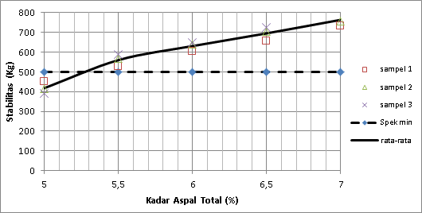

Source: Research

**Figure 2** Graph of asphalt grade relationship with stability

**4.2 Asphalt Grade Relationship With Flow**

Flow is the magnitude of the vertical deformation samples that occur from the beginning loading to a stable conditionmaximum until the sample is destroyed [5]. The relationship between asphalt level and flow can be seen in Figure 3 below.

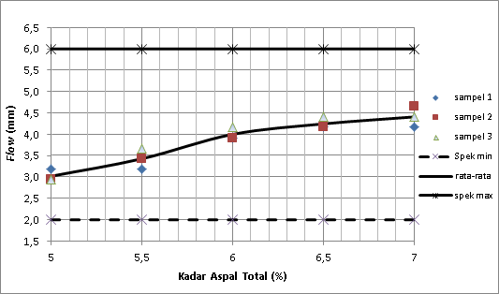

Source: Research

**Figure 3** Graph of asphalt grade relationship with flow

**4.3 Asphalt Grade Relationship With Marshall Quotient**

Marshall quotient is the quotient stability by melting with unit kg/mm [5]. The relationship between asphalt level and marshall quotient can be seen in Figure 4 below.

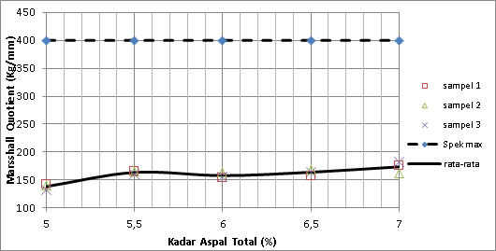

Source: Research

**Figure 4** Graph of asphalt grade relationship with Marshall quotient

**4.4 Asphalt Grade Relationship With Voids In Mix (VIM)**

Void in Mix (VIM) remaining cavity volume after the asphalt concrete mix is ​​compacted [5]. The relationship between asphalt level and VIM can be seen in Figure 5 below.

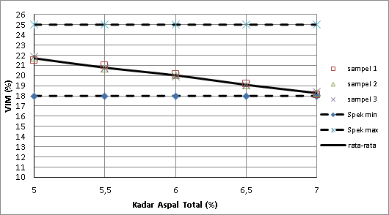

Source: Research

**Figure 5** Graph of asphalt grade relationship with Void in Mix (VIM)

**4.5 Asphalt Grade Relationship With Voids In Mineral Agregat (VMA)**

Void In Mineral Aggregate (VMA) is particle void spaces between the aggregates at a pavement, including air voids and effective asphalt volume [5]. The relationship between asphalt level and VMA can be seen in Figure 6 below.

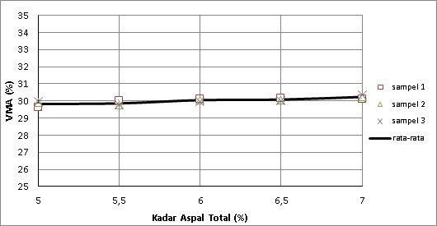

Source: Research

**Figure 6** Graph of asphalt grade relationship with Void In Mineral Aggregate (VMA)

**4.6 Asphalt Grade Relationship With Voids Filled Bitumen (VFB)**

Void Filled Bitumen (VFB) is part of the test object filled with asphalt. This VFB value is proportional to the VMA value [6]. The relationship between asphalt level and VFB can be seen in Figure 7 below.



Source: Research

**Figure 7** Graph of asphalt grade relationship with Void Filled Bitumen (VFB)

**4.7 Determining Optimum Asphalt Level**

The bar-chart method used to determine the optimum asphalt level in Porous Asphalt is as shown in Figure 8. The optimum asphalt level value in Porous Asphalt can be determined by finding the middle value of the range of maximum and minimum asphalt level that meets the requirements of Stability, Flow, Marshall Quotient, and VIM- Marshall.



Source: Research

**Figure 8** Bar-Chart of optimum asphalt level

**4.8 Analysis of Porous Asphalt Mixture Characteristics at Optimum Asphalt Level**

After knowing the optimum asphalt level, a sample will be made using the optimum asphalt level (6.15%) and look for its characteristics as in Table 1.

**Table 1.** Characteristics of Porous Asphalt mixture at optimum asphalt level

|  |  |  |
| --- | --- | --- |
| Mixed | Optimum Asphalt | Mixed |
| Characteristics | Level (6.15%) | Requirements |
| Stability (kg) | 636,32 | Min. 500 |
| Flow (mm) | 4,00 | 2-6 |
| MQ (Kg/mm) | 159,15 | Max 400 |
| VIM (%) | 19,828 | 18-25 |
| VMA (%) | 30,121 | - |
| VFB (%) | 34,173 | - |

Source: Research

**4.9 Results of Cantabro Test at Optimum Asphalt Level**

For durability purpose, porous asphalt wearing course should have good particle loss (ravelling) resistance in itself. To compare the ravelling resistance of the trial section and normal porous asphalt pavement, the particle loss values of the cores with steel wool and plain cores were measured in Cantabro test [3]. The Cantabro Abration Loss (CAL) value obtained according to the maximum specification must be 20% [7]. The results of the cantabro durability test get a Cantabro Abration Loss (CAL) value of 17.90%. This value has met the specifications.

**4.10 Results of Permeability Test at Optimum Asphalt Level**

Permeability Testing is an opportunity to get the permeability value of Porous Asphalt. Permeability is the ability of a porous medium to flow fluid. Any material with space in between is called porous, and if the empty spaces are interconnected, it will have permeability properties [1]. The permeability value obtained according to the specifications should be 0.1-0.5 cm/s [8]. The results of the permeability test get the horizontal and vertical permeability values ​​of 0.145 and 0.152 cm/second. This value already meets the specifications.

**4.11 Results of Indirect Tensile Strength Test at Optimum Asphalt Level**

ITS (Indirect Tensile Strength Test) is used to determine the tensile properties of the asphalt mixture at a speciﬁed temperature and loading rate. /is test was carried out in accordance with JTG E20-2011, chopped basalt ﬁbers with a length of 9 mm, content of 0.3% and length of 12 mm and content of 0.3% were mixed into porous asphalt mixture, respectively [9]. The results of the ITS test get an ITS value of 158.88 KPa. The ITS value has no specifications.

**4.12 Results of Unconfined Compressive StrengthTest at Optimum Asphalt Level**

UCS (Unconfined Compressive Strength Test) test to get the value of compressive strength or compressive strength of Porous Asphalt. Compressive strength is a method to determine the value of the compressive force of a mixture of pavements. Compressive strength is the ability of the pavement layer to withstand vertical loads expressed in kg or lb [10]. The test equipment used is a UTM (Universal Testing Machine). The results of the UCS test get a UCS value of 916,343 Kpa. UCS values ​​are unspecified.

**5. Conclusion and Suggestion**

**5.1 Conclusion**

In accordance with the results of the study, the following conclusions can be drawn:

1. The optimum asphalt level value in Porous Asphalt mixture using aggregates from Karangasem and 60/70 penetration bitumen is 6.15% and has a Marshall characteristic value of 636.32 kg (min. 500 kg specification), Flow value of 4, 0 mm (2-6 mm specification), the Marshall Quotient value is 159.15 kg/mm ​​(max. 400 kg/mm ​​specification), and the Marshall VIM value is 19.828% (18-25%). All Marshall characteristic values ​​meet the specifications of the Australian Asphalt Pavement Association (AAPA).

2. Characteristics of Porous Asphalt mixture at optimum asphalt level using aggregates from Karangasem and 60/70 penetration bitumen produces Cantabro values ​​of 17.90% (max. 20% specification), vertical and horizontal permeability values ​​of 0.145 and 0.152 cm/second ( specifications 0.1-0.5 cm/second), the ITS value is 158.88 Kpa, and the UCS value is 916,343 Kpa.

**5.1 Suggestion**

In accordance with the results of the study, the following suggestions can be put forward:

1. This research is still far from perfect, for further research its use can be developed by changing the previous research variables, including:

• Changing the type or type of asphalt.

• Use aggregates from other areas, or use other used aggregates as coarse, fine or filler aggregates.

2. It is necessary to make the aggregate gradation and specifications for Porous Asphalt mixtures in Indonesia.

**References**

[1] M. Tumpu, S. Gusty, M. W. Tjaronge, and H. Parung, “Permeability Measurement of Hot Mix Cold Laid Containing Asbuton as Porous Asphalt,” *IOP Conf. Ser. Earth Environ. Sci.*, vol. 921, no. 1, pp. 0–5, 2021, doi: 10.1088/1755-1315/921/1/012065.

[2] N. N. Luxman *et al.*, “Effect of compaction temperature on porous asphalt performance,” *IOP Conf. Ser. Earth Environ. Sci.*, vol. 244, no. 1, 2019, doi: 10.1088/1755-1315/244/1/012011.

[3] N. E. Jasni *et al.*, “Marshall stability of porous asphalt mixture incorporating kenaf fiber,” *Arch. Civ. Eng.*, vol. 68, no. 1, pp. 379–393, 2022, doi: 10.24425/ace.2022.140174.

[4] A. I. Candra, S. W. Mudjanarko, Y. C. S. Poernomo, and P. Vitasmoro, “Analysis of the Ratio of Coarse Aggregate to Porous Asphalt Mixture,” *J. Phys. Conf. Ser.*, vol. 1569, no. 4, 2020, doi: 10.1088/1742-6596/1569/4/042029.

[5] A. Rahmawati and R. N. Hidayat, “Kinerja Campuran Aspal Porus yang Dimodifikasi dengan Lateks,” *Semesta Tek.*, vol. 24, no. 1, pp. 47–61, 2021, doi: 10.18196/st.v24i1.11724.

[6] S. Anam and H. Pratikto, “PENGUJIAN PERKERASAN ASPAL PORUS DENGAN PENAMBAHAN TREAD BAN BEKAS PADA UJI MARSHALL Fakultas Teknik Universitas Kadiri,” *Ukarst J. Univ. Kadiri Ris. Tek. Sipil*, vol. 2, no. 2, pp. 154–163, 2018.

[7] “1,2,,3,” vol. 3, no. 2, pp. 167–172, 2020.

[8] N. T. Sembung, T. K. Sendow, and S. Palenewen, “Analisa Campuran Aspal Porus Menggunakan Material Dari Kakaskasen Kecamatan Tomohon Utara Kota Tomohon,” *J. Sipil Statik*, vol. 8, no. 3, pp. 345–352, 2020.

[9] S. Wang, A. Kang, P. Xiao, B. Li, and W. Fu, “Investigating the effects of chopped basalt fiber on the performance of porous asphalt mixture,” *Adv. Mater. Sci. Eng.*, vol. 2019, 2019, doi: 10.1155/2019/2323761.

[10] T. Bebas and D. A. N. P. Campuran, “Dingin Aspal Porus Dengan Rapid Curing Danang Pasc Karyono Dwiraharjo Nim I 0105057 Tinjauan Kuat Tarik Tidak Langsung , Kuat,” 2010.